COVID-19 Trauma-Informed

Leadership Exercises

Exercise 1: Continuum of Response:
Healthcare workers and leaders demonstrate a wide variety of responses to COVID-19 collective trauma.
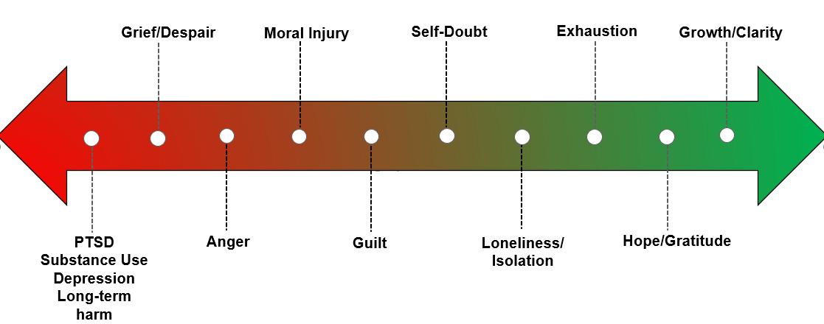
Case example:
Imagine three leaders within a health system:
“Carmen” is highly social and thrives when spending time with friends or doing social activities. She has two teenage children and everyone in her home is now fully vaccinated. Carmen feels a sense of relief and freedom. She feels excited to “move on” and enjoy some sense of “normalcy.” Her goal is to put the experiences of COVID-19 behind her and return to “business as usual.”
“Ron” has two young children who are not yet vaccinated. Ron’s partner is suffering potentially long-term health issues from long COVID. As a result, Ron remains cautious about social engagements and has complicated feelings about his work and family responsibilities. He feels concerned, isolated, exhausted and is grieving. His goal is to show staff empathy and support them in caring for themselves and others.
“Sally” feels she has bent over backwards to accommodate staff, often at the expense of her own family’s needs. The patients do not stop coming even though the staff is stretched thin. She feels like Lucy frantically trying to attend to the ever-running conveyer belt of chocolates. Sally is feeling tired and is wondering how much longer she, and her health system, need to remain flexible. She is frustrated with staff, who she experiences as “entitled.” Her goal is to motivate staff to increase their work capacity.
- How do you imagine these experiences/goals might impact what they do with staff in re:
  - Expectations

  - Inquiring about staff experiences and needs

  - Staff behaviors that they might encourage or promote

Exercise 2: Understanding Enactments Using Karpman’s Drama Triangle
The Stephen B. Karpman, M.D. Drama Triangle (1968, 2008, 2020) can be a useful tool in understanding and resolving conflict in professional and personal relationships.¹⁻³ Each point of the triangle represents roles that people are pulled towards and often switch between during times of stress. Each role is important, valid, and contains some truth and untruths.
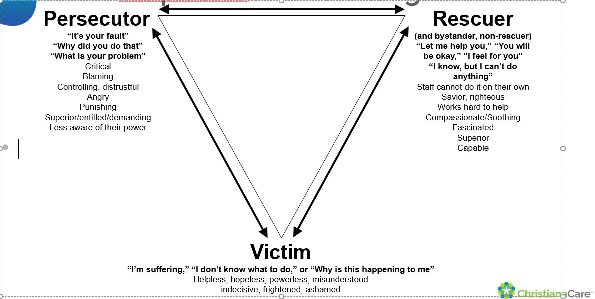

COPYRIGHT © 1967, 2008, 2020 by Stephen B. Karpman, M.D.
Adapted by ChristianaCare for the American Medical Association STEPS Forward.

Returning to our vignettes of Carmen, Ron, and Sally – Imagine that these three leaders are tasked with collaborating to develop an initiative.
- Who do you think would find themselves in which role of Karpman’s (2019) Drama Triangle?

- How might they feel about one another? Could we anticipate any communication challenges as a result?

- What organizational values and behaviors could help them find common ground?

Exercise 3: Self-Compassion
- Which role(s) have you occupied of Karpman’s Drama Triangle in the past year?

- Circle the strongest feelings you experienced being stuck in the predominant role you identified.

Angry | Sad | Anxious | Hurt | Embarrassed | Happy
Grumpy | Disappointed | Afraid | Jealous | Isolated | Thankful
Frustrated | Mournful | Stressed | Betrayed | Self-Conscious | Trusting
Annoyed | Regretful | Vulnerable | Isolated | Lonely | Comfortable
Defensive | Depressed | Confused | Shocked | Inferior | Content
Spiteful | Paralyzed | Bewildered | Deprived | Guilty | Excited
Impatient | Pessimistic | Skeptical | Victimized | Ashamed | Relaxed
Disgusted | Tearful | Worried | Aggrieved | Repugnant | Relieved
Offended | Dismayed | Cautious | Tormented | Pathetic | Elated
Irritated | Disillusioned | Nervous | Abandoned | Confused | Confident

- How did being stuck in that role influence your behavior? What do you feel you did well? What did you feel you did not-so-well?

- Self-Compassion: How would you support a colleague who shared the above information with you? What might you say?

Exercise 4: Trauma-Informed Leadership Strategies During Remembrance
Let’s focus on four important tasks during the remembrance phase of recovery. Please brainstorm two strategies or practices to target each of the following tasks:
  - 2 strategies to promote team wellbeing (remember, many organizations erroneously default to individual wellbeing, but collective trauma demands team focus)

  - 2 strategies to acknowledge and normalize the range of experiences and feelings of your team.

  - 2 strategies to recognize or spotlight good behaviors and help people feel valued

  - 2 informal or formal data collection strategies in re: caregiver experience and needs so that we can identify lessons learned in the future.

Example courtesy of ChristianaCare.
References:
- Karpman S. Fairy tales and script drama analysis. Transactional Analysis Bulletin. 1968:7(26):39-43. Accessed August 3, 2022. https://karpmandramatriangle.com/pdf/DramaTriangle.pdf
- Karpman S. A Game Free Life: The New Transactional Analysis of Intimacy, Openness, and Happiness. Drama Triangle Publications; 2014.
- Karpman S. Collected Papers in Transactional Analysis. Drama Triangle Publications; 2019.
Disclaimer: AMA STEPS Forward™ content is provided for informational purposes only, is believed to be current and accurate at the time of posting, and is not intended as, and should not be construed to be, legal, financial, medical, or consulting advice. Physicians and other users should seek competent legal, financial, medical, and consulting advice. AMA STEPS Forward™ content provides information on commercial products, processes, and services for informational purposes only. The AMA does not endorse or recommend any commercial products, processes, or services and mention of the same in AMA STEPS Forward™ content is not an endorsement or recommendation. The AMA hereby disclaims all express and implied warranties of any kind related to any third-party content or offering. The AMA expressly disclaims all liability for damages of any kind arising out of use, reference to, or reliance on AMA STEPS Forward™ content.
Source: AMA. Practice transformation series: collective trauma: responding effectively as an organization. 2022.

