Add logo here
[Practice Name]
Acknowledgment of Receipt of Keys

This is to acknowledge that I, |  | , have received the following keys to the
office/facility/lockers/others.

Key type | Office location | Date received | Initials | Date returned | Initials

Comments:

I understand that it is my responsibility to follow all guidelines and policies as set forth in this acknowledgment and in the [PRACTICE POLICY]. Any unauthorized duplication of these keys can result in disciplinary action, including termination. It is my responsibility to notify the owner/practice president if any keys are misplaced, lost, or stolen. I understand that the keys may not be duplicated without the express written consent of the practice president or the practice consultants.
I will safeguard the keys at all times to prevent misuse or unauthorized access to the office/facility/lockers/others. I understand that the keys have been provided to allow convenient access to the office/facility/locker/others, and may contain expensive, valuable equipment, and personal or confidential material/belongings. I understand that I may not lend these keys to fellow employees or non-employees who have not been authorized to possess these keys. I understand that the keys are the property of the practice and upon my separation from the practice, I shall return all keys to my supervisor.

Employee signature:

Print name: |  | Print title:

Date: |  | Date:

Disclaimer: While the information and guidance provided in this document is believed to be current and accurate at the time of posting, it is not intended to be and should not be construed to be or relied upon as legal, financial, or consulting advice. Before use, each document should be tailored to the unique nature of your practice, including applicable state law. Consult with an attorney and other advisors. References and links to third parties do not constitute an endorsement or sponsorship by the AMA, and the AMA hereby disclaims all express and implied warranties of any kind in the information provided.

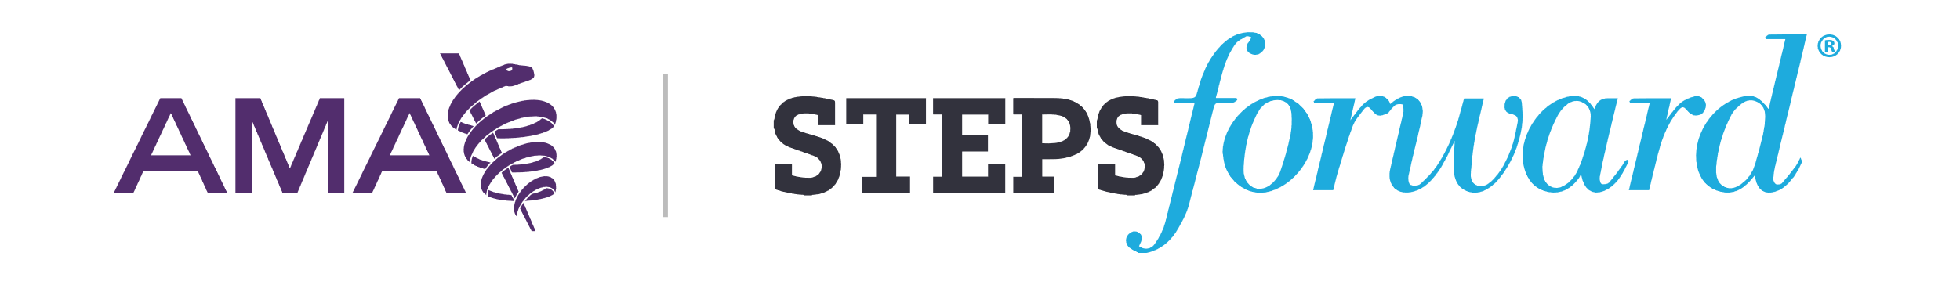

© 2023 American Medical Association. All rights reserved.

