Add logo here
Employee Warning Notice

EMPLOYEE INFORMATION

Employee name: |  |  | Date:

Employee ID: |  |  | Job title:

Manager: |  |  | Department:

TYPE OF WARNING

First Warning | Second Warning | Final Warning
TYPE OFFENSES

Tardiness/Leaving Early  Substandard Work |  | Absenteeism  Violation of Safety Rules | Violation of Company Policies  Rudeness to Customers/Coworkers |  | Violation of Company Policies | Violation of Company Policies | Violation of Company Policies | Violation of Company Policies
Other:

DETAILS

Description of infraction:

Plan for improvement:

Consequences of further infractions:

ACKNOWLEDGEMENT OF RECEIPT OF WARNINGS

By signing this form, the employee confirms they understand the information in this warning. The employee also confirms that the warning and a plan for improvement have been discussed with management. Signing this form does not necessarily indicate that the employee agrees with this warning.
Employee signature | Date
Manager signature | Date
Witness signature (if employee understands the warning but refuses to sign) | Date

Disclaimer: While the information and guidance provided in this document is believed to be current and accurate at the time of posting, it is not intended to be and should not be construed to be or relied upon as legal, financial, or consulting advice. Before use, each document should be tailored to the unique nature of your practice, including applicable state law. Consult with an attorney and other advisors. References and links to third parties do not constitute an endorsement or sponsorship by the AMA, and the AMA hereby disclaims all express and implied warranties of any kind in the information provided.

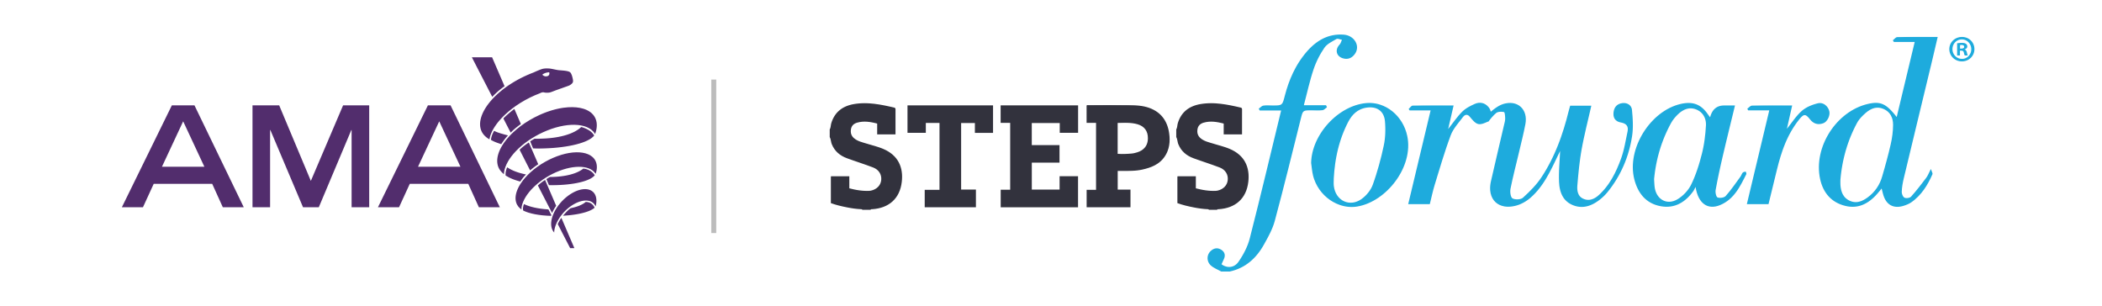

© 2023 American Medical Association. All rights reserved.

