Add logo here

NOTE: Practices should verify local and state regulations regarding when a drug test can be conducted. This form should only be completed when taking a drug test is appropriate.
I hereby consent to allow [facility name] to take a specimen of my hair, urine, or blood and submit it to a laboratory testing service for a pre-employment, random or reasonable suspicion drug test. I further consent to allow the laboratory testing service to make the results of the drug test available to [Practice Name].
I understand that [where allowed by state law] positive test results, refusal to be tested, or any attempt to affect the test sample or the results will result in withdrawal of my application for employment or withdrawal of any provisional employment offer I have received from [Practice Name], or termination of employment, depending on when the results are received.
I agree to hold harmless and release from all claims [Company Name] and its agents (including the above-named facility) from any liability arising in whole or part from the collection of specimens, testing, and the appropriate use of the information from such testing.

Employee/applicant name:

Employee/applicant signature: |  | Date:

Disclaimer: While the information and guidance provided in this document is believed to be current and accurate at the time of posting, it is not intended to be and should not be construed to be or relied upon as legal, financial, or consulting advice. Before use, each document should be tailored to the unique nature of your practice, including applicable state law. Consult with an attorney and other advisors. References and links to third parties do not constitute an endorsement or sponsorship by the AMA, and the AMA hereby disclaims all express and implied warranties of any kind in the information provided.
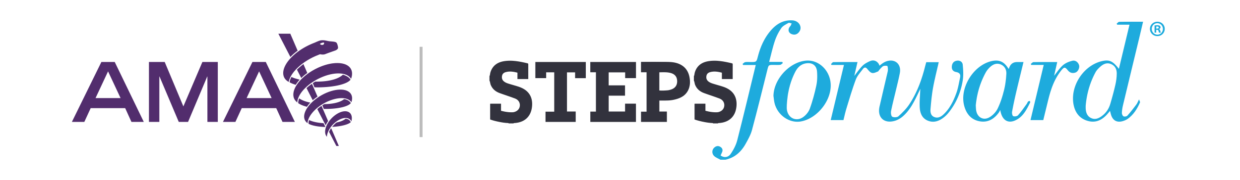

© 2023 American Medical Association. All rights reserved.

